ROS 2 Gazebo Simulation and SLAM Mapping Implementation for TurtleBot4

Abstract
This project presented the development, simulation, and mapping execution of a TurtleBot4 robot using ROS 2 Jazzy and the Gazebo simulation environment. The system was designed to simulate robot motion, environment interaction, and LiDAR sensor integration to execute Simultaneous Localization and Mapping (SLAM) within a virtual environment. The TurtleBot4 was spawned in a simulated warehouse-style world, and movement commands were issued using ROS 2 topics. Due to the high computational constraints of virtual machine environments (UTM), the simulation was optimized using headless execution and strict time synchronization. The project successfully demonstrated the integration of ROS 2 communication pipelines, LiDAR-based SLAM, and manual robot control using velocity commands visualized through RViz.

Table of Contents
• Introduction
• Objectives
• System Overview
• Implementation Methodology
• Manual Control Explanation
• Mapping and SLAM Explanation
• Simulation Environment
• Testing and Results
• Challenges Faced
• Conclusion Appendix A. Source Code and Commands References

Student Name | Student ID
Saif Eddin Jamil Mhaisen | 0223489
Wateen Abusaleh | 0228252
Huda Alsayed | 2213316
Yarah alhindi | 2213245

1. Introduction

Robot simulation is a critical phase in modern robotics development, providing a safe and controlled virtual environment for testing algorithms before physical deployment. ROS 2 provides a robust communication framework for such applications, while Gazebo offers highly accurate physics simulation for robot kinematics and environment interaction. In this project, a TurtleBot4 robot was simulated using ROS 2 Jazzy. The robot was equipped with a simulated LiDAR sensor and a differential drive system to navigate and map a virtual environment. The primary goal of the project was to demonstrate successful robot spawning, ROS topic communication, sensor data integration, and the execution of SLAM algorithms to generate a 2D occupancy grid map of the environment.

2. Objectives
The objectives of this project were to:
- Initialize a ROS 2 Jazzy workspace and launch the TurtleBot4 simulation.
- Spawn the TurtleBot4 inside a Gazebo environment containing walls and obstacles.
- Optimize simulation performance for virtual machine constraints using headless execution.
- Integrate and synchronize simulation time across all active ROS 2 nodes.
- Control the robot's movement manually using differential drive velocity commands.
- Implement the SLAM Toolbox to generate an environment map using LiDAR data.
- Visualize the robot model, LiDAR scans, and the generated map in real-time using RViz.

3. System Overview

The system was composed of the following core components:

3.1 ROS 2 Jazzy Middleware

ROS 2 Jazzy acted as the communication backbone, managing the publication and subscription of messages between the Gazebo simulator, the SLAM algorithms, and the visualization tools..

3.2 Gazebo Simulation

Gazebo provided the 3D physics environment. It simulated the robot's physical interactions, wheel odometry, and LiDAR laser collisions with the surrounding virtual walls.

3.3 TurtleBot4 Architecture
The project utilized the standard TurtleBot4 URDF and plugins. The robot model included a base chassis, a differential drive controller plugin, and a top-mounted LiDAR sensor.

3.4 Rviz Visualization
RViz was utilized as the primary graphical interface to view the robot's internal state. It visualized the base_link relative to the odom frame, plotted the raw laser scan points, and dynamically rendered the map being constructed.

3.5 ROS Topics
The following table outlines the active ROS 2 topics utilized to achieve robot motion and mapping:
Figure 1 Active ROS 2 communication topics used in the project.

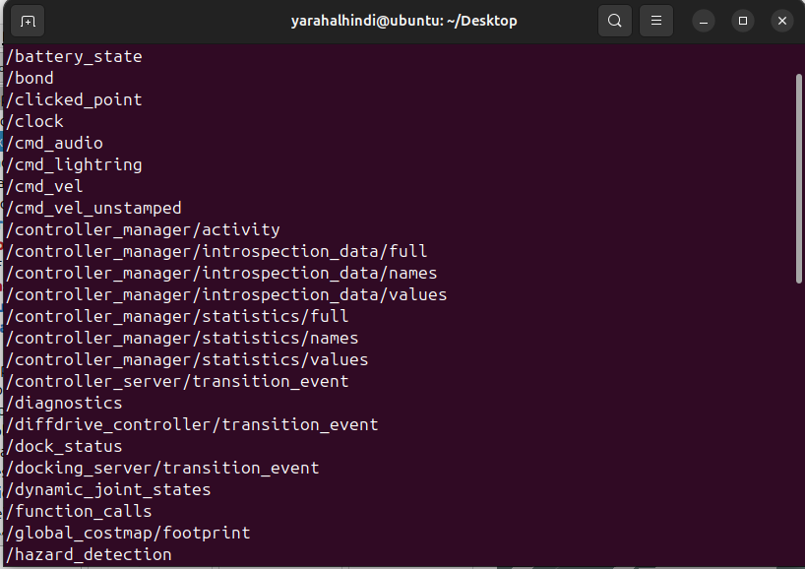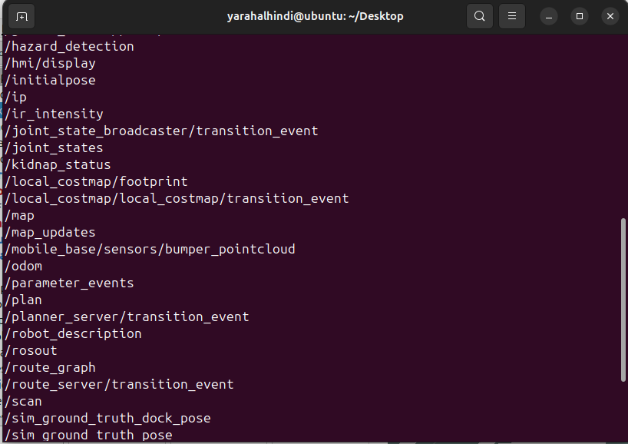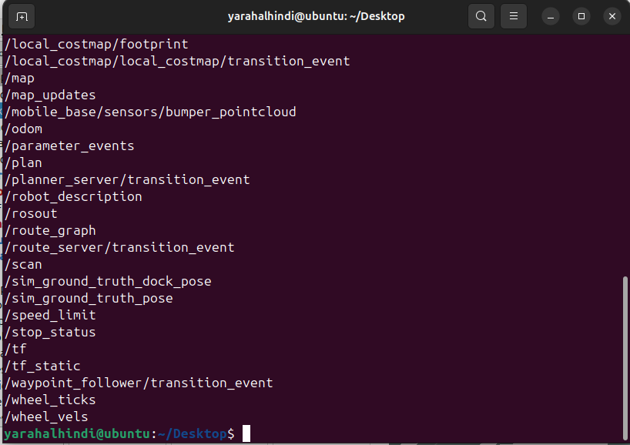

Topic | Purpose
/cmd_vel | Received geometry_msgs/msg/Twist commands to drive the robot.
/odom | Published odometry data calculating the robot's relative position.
/scan | Published 360-degree LiDAR laser scan data.
/tf | Published coordinate transforms (e.g., odom to base_link).
/map | Published the 2D occupancy grid generated by the SLAM Toolbox.

4. Implementation Methodology

4.1 TurtleBot4 Workspace And Gazebo Spawning
The simulation was launched from the standard TurtleBot4 workspace. To spawn the robot, the environment variables and ROS 2 setup files were sourced. The robot was spawned using the turtlebot4_gz_bringup package, which loaded the URDF model, physics plugins, and the virtual world.

4.2 Headless Simulation optimization
Running the Gazebo GUI alongside RViz caused severe resource exhaustion and system freezing within the UTM virtual machine. To resolve this, the Gazebo environment was executed in "headless" mode. The physics engine ran silently in the background by passing the argument headless:=true, which successfully freed computational resources for the SLAM node and RViz visualization.

4.3 Time Synchronization Integration
A critical step in the methodology was forcing the nodes to use simulation time rather than the host computer's system clock. Without this, RViz dropped incoming transform messages (displaying a "timestamp is earlier than all data" error), causing the robot model to appear white and preventing map generation. The parameter use_sim_time:=true was appended to all launch commands to synchronize the SLAM algorithms and RViz with Gazebo's internal clock.
Figure 2 LiDAR scan visualization using RViz2.

5. Manual Control Explanation
The robot's differential drive system was controlled by publishing geometry_msgs/msg/Twist messages directly to the /cmd_veltopic via the terminal.
The motion parameters used were:
Parameter | Description
linear.x | Set forward/backward velocity in meters per second (m/s).
angular.z | Set rotational velocity in radians per second (rad/s).
To prevent the SLAM algorithm from experiencing "rubber-banding"—a phenomenon where the robot jumps backward because the LiDAR data lags behind the rapid wheel odometry—the velocity was intentionally kept very low. For example, the following command was used to execute a slow, stable mapping curve: ros2 topic pub /cmd_vel geometry_msgs/msg/Twist "{linear: {x: 0.05}, angular: {z: 0.1}}"

6. Mapping and SLAM Explanation
Simultaneous Localization and Mapping (SLAM) was achieved using the turtlebot4_navigation package, which wraps the ROS 2 SLAM Toolbox. When initiated, the SLAM node subscribed to the /scan (LiDAR) and /tf (transforms) topics.
As the robot was manually driven through the environment, the SLAM algorithm matched the current LiDAR scans against previously recorded scans (scan matching) while utilizing wheel odometry to estimate motion. The output was a 2D occupancy grid published to the /map topic, where white pixels represented free space, black pixels represented solid obstacles (walls), and grey pixels represented unexplored areas.

Figure 3 Robot movement controlled using ROS 2 /cmd_vel commands.

7. Testing and Results
The simulation environment was hosted in Gazebo and visualized in RViz. Due to the headless implementation, all visual confirmation of the environment relied on sensor data plotted in RViz. The Fixed Frame in RViz was set to odom to ensure the robot visually traversed the screen relative to its starting position, allowing the map to expand outwards properly as new data was processed.
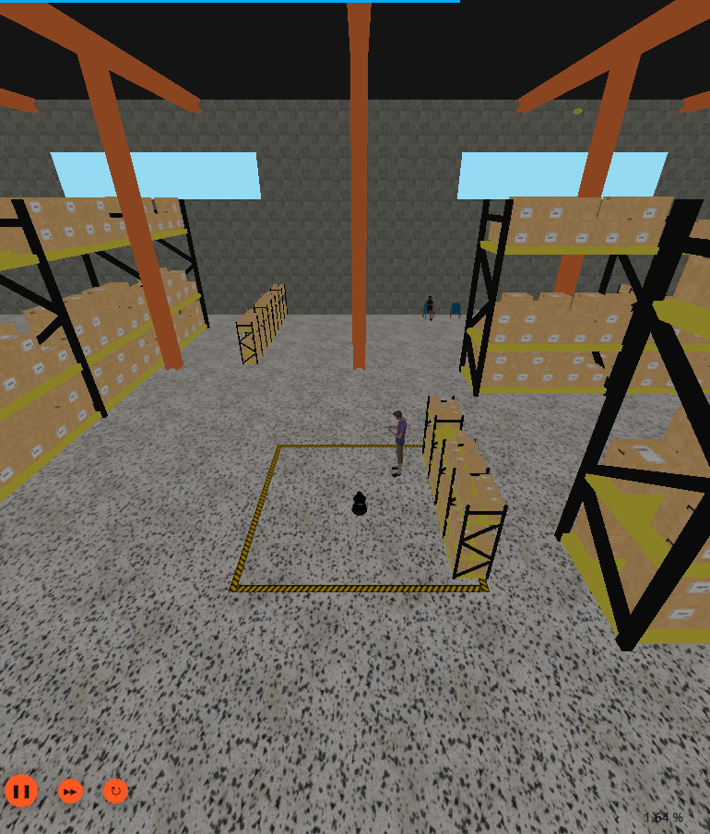
[Figure 1 Placeholder: Gazebo Simulation Environment] Figure 1. The virtual warehouse environment in Gazebo (prior to headless execution).

8. Testing and Results
The system was tested by initiating all nodes and observing the mapping process in RViz.
- The TurtleBot4 was successfully spawned and responded to /cmd_vel inputs.
- RViz correctly visualized the robot model without TF timestamp errors.
- The SLAM Toolbox successfully generated a distinct environment map that expanded accurately as the robot moved.
- Topic communication was verified using terminal commands such as ros2 topic list.

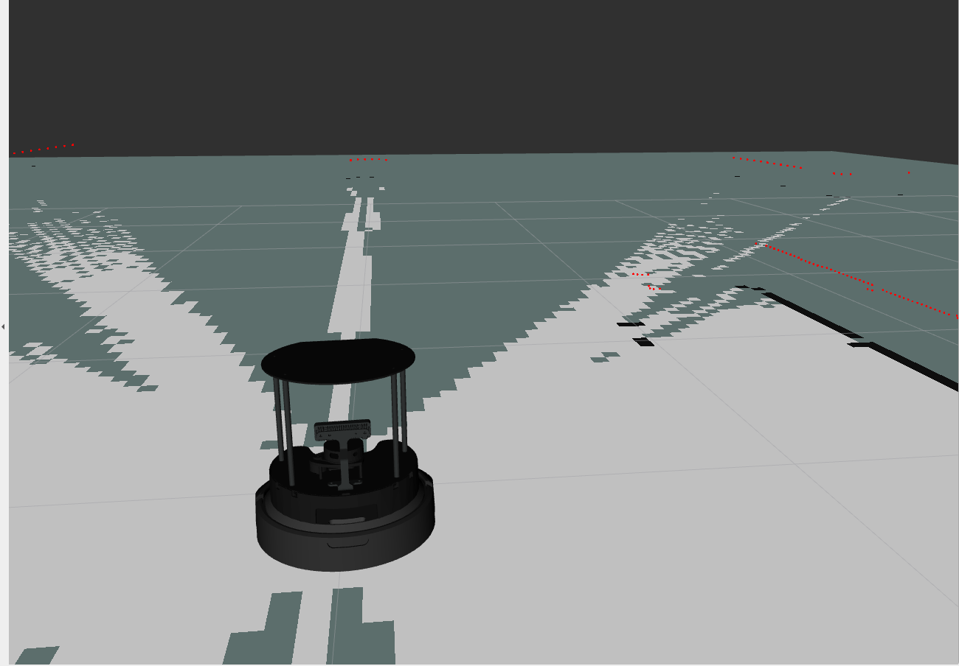
[Figure 2 Placeholder: RViz Visualization and Mapping] Figure 2. RViz interface displaying the TurtleBot4, the /scanpoints, and the generated /map grid.

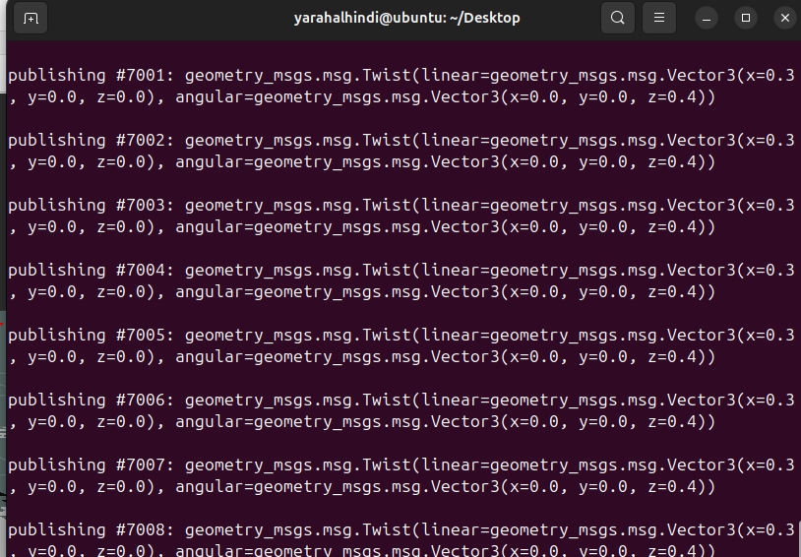
[Figure 3 Placeholder: Manual Teleoperation] Figure 3. Terminal executing continuous Twist messages to drive the robot.

9. Challenges Faced
Developing this simulation in a virtual machine presented severe system constraints that required strict engineering workarounds:
Challenge | Solution
System Freezing (High CPU/RAM) | The Gazebo GUI overloaded the VM. Solved by launching Gazebo with the headless:=trueparameter, relying purely on RViz for visualization.
DDS Shared Memory Corruption | Repeatedly terminating nodes caused [RTPS_TRANSPORT_SHM Error]. Solved by forcing a full UTM restart and running killall -9 gz to clear lingering processes.
RViz Rendering Errors (White Robot) | RViz dropped messages due to clock desynchronization. Solved by appending use_sim_time:=true to the SLAM and RViz launch files.
SLAM Rubber-banding | Fast movement caused the SLAM map to snap backward. Solved by reducing publication speeds to linear: {x: 0.05} to allow LiDAR processing to match wheel odometry.

10. Conclusion
This project successfully demonstrated the simulation of a TurtleBot4 using ROS 2 Jazzy and Gazebo. Despite significant hardware virtualization constraints, the team successfully engineered a pipeline utilizing headless simulation execution and strict time synchronization to achieve stable performance. The robot was accurately controlled using ROS 2 velocity topics, and the SLAM Toolbox was successfully deployed to translate simulated LiDAR data into a precise 2D environment map. The implemented mapping system establishes a complete foundational framework for future autonomous navigation and localization tasks.

Appendix A — Source Code and Commands
A.1 Environment Setup and Cleanup
# Force kill any stuck Gazebo processes in memory
killall -9 gz

A.2 Terminal Startup Commands (Executed in separate windows)
# Terminal 1: Launch Gazebo in headless mode
cd ~/turtlebot4_ws
source install/setup.bash
ros2 launch turtlebot4_gz_bringup turtlebot4_gz.launch.py headless:=true

# Terminal 2: Launch SLAM Toolbox with simulated time
cd ~/turtlebot4_ws
source install/setup.bash
ros2 launch turtlebot4_navigation slam.launch.py use_sim_time:=true

# Terminal 3: Launch RViz visualization with simulated time
cd ~/turtlebot4_ws
source install/setup.bash
ros2 launch turtlebot4_viz view_robot.launch.py use_sim_time:=true
A.3 Manual Motion Commands
# High-speed circular motion (caused rubber-banding in VM)
ros2 topic pub /cmd_vel geometry_msgs/msg/Twist "{linear: {x: 0.3}, angular: {z: 0.4}}"

# Optimized low-speed motion for stable SLAM mapping
ros2 topic pub /cmd_vel geometry_msgs/msg/Twist "{linear: {x: 0.05}, angular: {z: 0.1}}"
from geometry_msgs.msg import Twist

A.4 Python Mapping Motion Script
The following Python script was developed to automate the differential drive movement during the SLAM mapping phase. Instead of relying on manual terminal inputs, this ROS 2 node publishes low-velocity geometry_msgs/msg/Twistmessages to the /cmd_vel topic. The velocities are kept deliberately low (linear.x = 0.05, angular.z = 0.1) to ensure the LiDAR scan matching algorithms in the SLAM Toolbox remain synchronized with the wheel odometry, effectively preventing "rubber-banding" within the virtual machine environment.
Python
import rclpy
from rclpy.node import Node
from geometry_msgs.msg import Twist
import time

class TurtleBot4Mapper(Node):
def __init__(self):
super().__init__('turtlebot4_mapper_node')
# Create a publisher on the /cmd_vel topic
self.publisher_ = self.create_publisher(Twist, '/cmd_vel', 10)
self.get_logger().info('TurtleBot4 Mapping Motion Node Started.')

def move_robot(self, linear_vel, angular_vel, duration_sec):
msg = Twist()
msg.linear.x = float(linear_vel)
msg.angular.z = float(angular_vel)

start_time = time.time()
self.get_logger().info(f'Moving -> Linear: {linear_vel}, Angular: {angular_vel}')

# Publish the velocity for the specified duration
while (time.time() - start_time) < duration_sec and rclpy.ok():
self.publisher_.publish(msg)
time.sleep(0.1) # Publish rate of 10Hz

self.stop_robot()

def stop_robot(self):
msg = Twist()
msg.linear.x = 0.0
msg.angular.z = 0.0
self.publisher_.publish(msg)
self.get_logger().info('Robot Stopped.')

def main(args=None):
rclpy.init(args=args)
mapper_node = TurtleBot4Mapper()

try:
# Optimized slow motion to allow SLAM to process LiDAR data without rubber-banding
mapper_node.move_robot(linear_vel=0.05, angular_vel=0.1, duration_sec=60.0)

except KeyboardInterrupt:
mapper_node.stop_robot()
mapper_node.get_logger().info('Motion interrupted by user.')
finally:
mapper_node.destroy_node()
rclpy.shutdown()

if __name__ == '__main__':
main()

References
- ROS 2 Documentation – https://docs.ros.org
- Gazebo Simulator Documentation – https://gazebosim.org
- Clearpath Robotics: TurtleBot4 User Manual – https://turtlebot.github.io/turtlebot4-user-manual/

